**Module Code & Module Title**

**CC5068NI– Cloud Computing & IoT**

**<<Project Title Here>>**

**Assessment Type**

**50% Group Report**

**Semester**

**2024 Spring**

**Group Members**

|  |  |
| --- | --- |
| **London Met ID** | **Student Name** |
| **22067065** | **Ryan Chalise** |
| **22067057** | **Dikshanta Chapagain** |
| **22067049** | **Amit Kumar Ray** |
| **22067066** | **Asmita Ghimire** |
| **22067059** | **Mohammad Nurullah** |

**Assignment Due Date: 10th May 2024**

**Assignment Submission Date:10th May 2024**

**Submitted to: Mr. Sugat Man Shakya**

**Word Count:**

*I confirm that I understand my coursework needs to be submitted online via Google Classroom under the relevant module page before the deadline in order for my assignment to be accepted and marked. I am fully aware that late submissions will be treated as non-submission and a mark of zero will be awarded*

**Acknowledgement**

We would like to extend our gratitude to everybody who was supportive in the successful project implementation.

First of all, our deepest gratitude goes to our project supervisor, Mr. Shishir Subedi, Mr. Sugat Man Shakya and Mr. Ayush Bhakta Pradhanga, for their precious advice, help, and motivation in our task completion. Their valuable knowledge and perceptive comments helped us design our work. Also, acknowledge the great help from our college for providing necessary resources and facilities to complete this project. Special thanks to Mr. Sugat Man Shakya for helping and his guidelines throughput our project. Also, big thanks to our Team Members for the good work, punctuality, caring attitude and encouragement that we received at every stage of the project.

**Abstract**

The main objective of the project was to develop a car that can be controlled from remote and use of IoT. We successfully were able to add wireless connectivity and a vehicle that understands motion into the car's design during the development of the car. During the testing phase all features, including obstacle detection, have been tested thoroughly to see if they are working well. For future use, our project can easily be applied in home automation, voice control, and in-camera photography/videography. We not only completed the project according to the objectives but also left a foundation for further creativity in the smart vehicle sector with the help of the Internet of Things.

Contents

1.Introduction 4

5. Future Works 15

5.1 Home Monitoring 15

5.2 Voice Control 16

5.3 Photography & Videography 17

6. Conclusion 18

***No table of figures entries found.***

**No table of figures entries found.**

# 1.Introduction

The internet has grown to be a necessity in our life. Most people rely on the Internet to do their jobs and to make their life easy. In fact, most people utilize a gadget that is connected to Internet. The Internet serves in a variety of purposes, including education, task-solving, process automation, entertainment, and data processing. The "Internet of Things," a technology, has started to find a place in our life to facilitate our varied activities without us feeling too exhausted. There are two types of Internet of Things (IoT): consumer and industrial. New technology model called the Internet of Things (IoT) foresees a global network of interconnected gadgets. IoT is widely acknowledged as one of the most significant fields of the future. [Cite: Lee, In, and Kyoochun Lee. "The Internet of Things (IoT): Applications, investments, and challenges for Enterprises." Business Horizons 58.4, pp. 431-440, 2015]. Everything is possible, thanks to the internet of things. One of the instances is our project, which involves a remote-controlled car.

This vehicle has a wifi module and with the help of that, it can be operated using a mobile device connection. This prototype if made for the real world, it can be used in a variety of ways, for instances: Valet parking, carrying heavy stuff in industries and more. The most significant use for this car is that it can assist in getting people to some endangered locations that are off- limits to them due to security concerns. The micro controller used in this prototype is node MCU. Wi-Fi has a significant impact on this. which the vehicle and mobile device can communicate.

This report presents the work of our team on the design and construction of a remote-controlled car. Our objective was to apply the theoretical knowledge we have acquired in our studies to a practical, hands-on project. The remote-controlled car we built is not just a toy, but a complex piece of idea that required us to explore various fields including electronics, mechanical design, and computer programming.

**1.1 Aims and Objectives**

The main aim of this project is to design and implement a remote-controlled car prototype using IOT technology for enhanced control and functionality with the following objectives:

* To develop a remote-controlled car which can be controlled with the help of wifi,
* To integrate IoT communication modules, such as NodeMCU,
* To integrate hardware components like motor driver, gear motor, jumper wires and wheels.
* To implement ultrasonic sensor which can detect obstacles

**2. Background**

**2.1 Overview**

The concept of remote control has been around for many decades now, with Nikola Tesla demonstrating the first radio-controlled boat back in 1898 [Cite: [Nikola Tesla: Father of Robotics (teslasociety.com)](https://teslasociety.com/robotics.htm)]. Since then, technology has evolved significantly, finding applications in various fields such as military, entertainment, and even space exploration.

In recent years, with the arrival of affordable electronics and the rise of the maker culture, building a remote-controlled car has become a popular project for students and those with passion alike. It provides hands-on experience of various aspects of engineering and computer science, including mechanical design, electronic circuit design, sensor integration, and programming.

Our project is a continuation of this tradition. We built this project with the idea that a remote-controlled car, which is not only functional and robust, but also integrates advanced features such as obstacle detection and autonomous navigation.

**2. 2 Design and Implementation**

Nowadays, wireless controlled cars are commonly found as toy-grade radio-controlled cars focusing on reducing production costs and hobby grade radio controlled, which can be customized. The 2.4 GHz frequency radio has been used in hobby-grade R/C Cars. Wi-Fi technology [Cite: John G. Proakis, “Digital Communications,” 5th Ed, Mc Graw Hill, Inc, New York, 2008.] has been implemented in wireless controlled car with high data rate (54Mbit/s +), but also high-power consumption. It is used when you need to connect directly to the internet, such as an internet-of-things (IoTs) device and have an external power source. [Cite: D. Jinbo, et al., “The Design and Implementation of of the Wireless Remote-Control Car,” 3rd International Conference on Computer and Electrical Engineering (ICCEE 2010), published in IACSIT Press, Singapore (2012)]

In this part, we are going to discuss the required materials used for this project, those are for hardware and software specifications.

1. Hardware Specifications, there are some hardware materials needed to fulfill this project, like Node MCU(ESP8266) as microcontroller, with integrated Wi-Fi Module as transmitter and receiver, Motor driver IC, DC motors and Power supply, chassis, and some other related equipment.
2. Node MCU(ESP8266)

A NodeMCU is a modern microcontroller developed by Arduino Enterprises. It functions similarly to an Arduino board but is compatible with various AVR p rocessors, allowing Arduino IDE C++ compilers to compile the entire package. The ESP team has implemented features that make the NodeMCU a c omprehensive kit, reducing the need for additional components to perform various tasks. The term 'Core' refers to the software group required to debug Arduino C++ headers using MCU language.

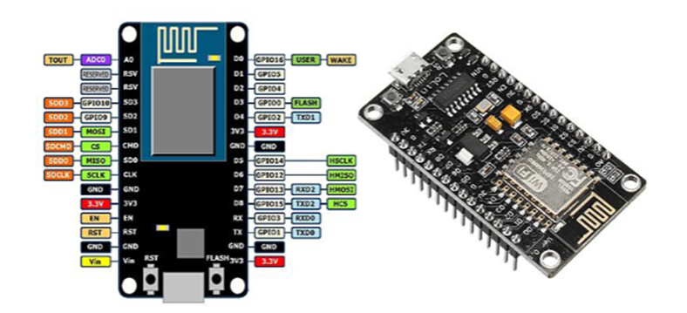

Same citation as in text

The ESP8266 module's innovation has led to the development of robust and complete systems, unlike the design methodology used for the Arduino core. This

was made possible through the ESP8266 Wi-Fi, which is based on the GitHub ESP8266 core website. The module serves as a platform for machine learning, bridging the gap between ESP8266 and NodeMCU. Figure illustrates the unit, which operates under the control of 802.11n and 802.11b networks. This means it can function as an access point (AP), a Wi-Fi system, or both simultaneously[Cite: <https://www.researchgate.net/publication/345098784_ESP_8266_Node_MCU_Based_Weather_Monitoring_System> ].

1. Breadboard [Cite: <https://link.springer.com/chapter/10.1007/978-1-4842-9218-1_3> ]

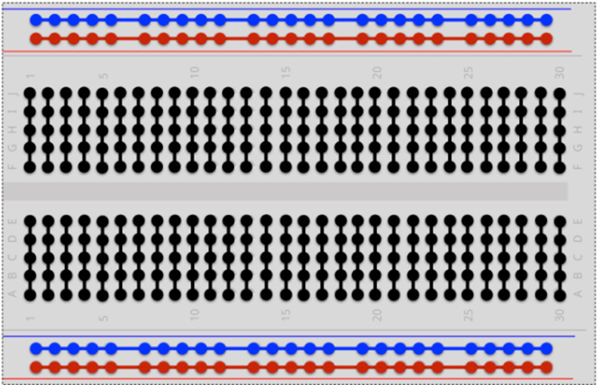

A breadboard is a tool used in electronics prototyping to quickly and easily build and test circuits without soldering. It consists of a plastic board with a grid of holes, interconnected by conductive metal strips underneath the surface. Components can be inserted into the holes and connected using jumper wires, allowing for rapid experimentation and iteration in circuit design. Breadboards are widely used by hobbyists, students, and professionals for temporary circuit assembly and testing.

1. Jumper wire [Cite: <https://www.freepatentsonline.com/6899560.pdf> ]

The jumper wire has opposite ends bent in the same direction, facing each other. The printed circuit board features slots on its upper or front surface, with through holes at opposite ends to allow insertion of the jumper wire ends. The jumper wire is inserted into the slot, bent at the ends, and soldered to the printed circuit pattern on the lower or rear surface of the breadboard for fixation.

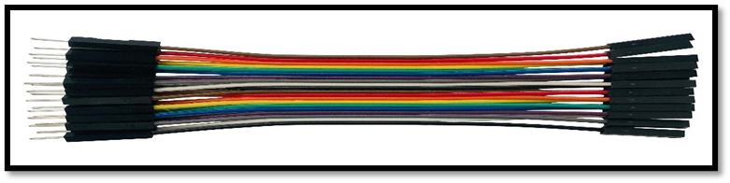

Depending on the aspect of the invention, the jumper wire structure may involve multiple jumper wires and slots, allowing for parallel arrangement and selective insertion of jump wires. Additionally, the slots can accommodate other electronic parts or devices, allowing for flexibility in circuit design.

1. Gear Motor [Cite for both fig and text:article: [Interfacing Single Axis 1:120 TT Gear Motor with Arduino - Electropeak](https://electropeak.com/learn/interfacing-single-axis-1-120-tt-gear-motor-with-arduino/) ]

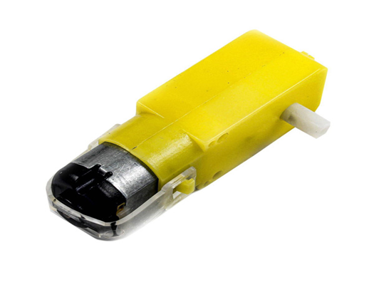

DC motors serve as a vital component for converting direct current electrical energy into mechanical power. These motors derive power from an external source, typically generating a uniform magnetic field within the stator. Interaction between this field and the magnetic field induced in the armature initiates rotational motion, propelling the motor. Varied in voltages and speeds, DC motors can be further enhanced by integrating gearboxes, which amplify torque while reducing rotational speed. Control over motor speed can be achieved through voltage adjustment, current regulation, or manipulation of armature resistance. This here, Single Axis 1:120 TT Gear Motor features a simple two-pin power supply connection, adding to its accessibility and versatility in electronics and robotics applications.

1. Motor driver [ CITE:

Journal name: International Journal of Hyperconnectivity and the Intemet of Things

Volume 5 • Issue 2 • July-December 2021

Title: Direction and Speed Control of DC Motor Using Raspberry PI and Python-Based GUI

Authors: Anup Kumar Kolya, Debasish Mondal, Alokesh Ghosh,Subhashree Basu

Page: 77-78]

The Direct Current (DC) Motor serves as a crucial electrical drive component, widely employed in diverse applications ranging from domestic to industrial settings such as rolling mills and electric vehicle tractions. Renowned for its affordability, reliable performance, low maintenance, and noise suppression,

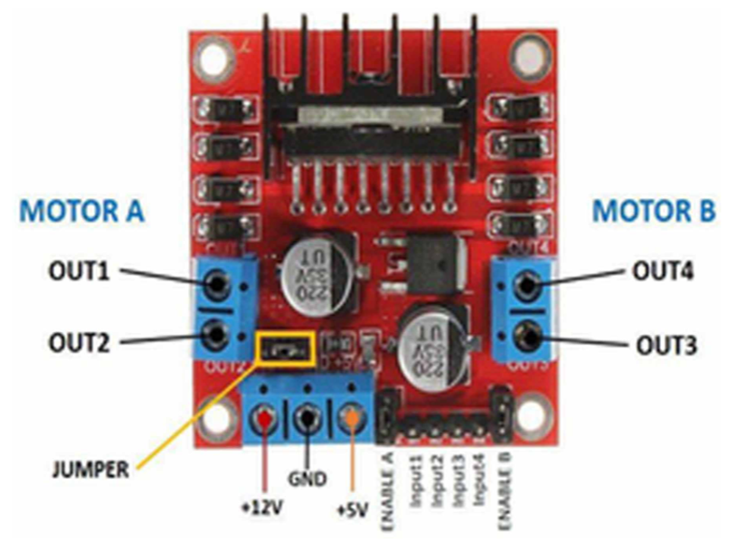

The DC motor efficiently converts electrical energy into mechanical power. Variants include series, shunt, and compound motors based on their electrical connections. This paper utilizes a miniature DC motor, with speed and direction controlled by the L293D motor driver IC. Capable of handling bidirectional drive currents up to 600 mA across voltages ranging from 4.5 V to 36 V, the L293D ensures effective motor management. Power for the motor can be supplied from any DC source or standard battery, with node mcu board configured programmatically for connectivity. Wiring facilitates connection between the DC motor and node mcu, while the motor driver IC and mcu are powered by the same battery, ensuring operational synergy.

**3. Development**

This Section of the report presents the step-by-step process of the project's development.

**Step 1:** **Planning and Design**

For any project to run planning the outline is crucial. For this project, different components like NodeMCU microcontroller, L298N motor driver, gear motor, battery, wheel, jumper wires and ultrasonic sensor are used. All the components were selected basis on their features and functionality. Once the components were selected the circuit layout was made.

**Step 2: Resource Collection**

The resources used to develop this IOT project are: NodeMCU, Ultrasonic sensor, Breadboard, Gear motor, Wheel, L298N motor driver, Jumper wires, Battery holder, Battery, and Chassis. Some of these components were provide from the resource department of college with the approval of Mr. Shishir Subedi. Some extra components like glue gun and soldering iron were also given by resource department. The components which were not found in resource department were brought from the external market source.

**Step 3: System Development**

The system is a remote-controlled car with obstacle detection.

**Phase1:** At first the chasis of the car was made and gear motor and wheels were glued in the chasis. The wires were soldered in the gear motor.

Figure 1: First phase prototype of car.

**Phase 2:** The second phase was mostly concerned with research about the GPIO pins of Node MCU and L298N motor driver and about the entire project.

**Phase 3**: In this phase the code implementation and testing were started.

Figure 2: Code execution on NodeMcu

**Phase 4:** In this phase all the wiring work has been done, and the required components were tested and glued in the chasis.

Figure 3: Wiring the components throughout appropriate pins.

**Phase 5:** The final prototype, remote controlled car with obstacle detection was ready.

Figure 4: The final prototype.

**4. Result and Findings**

The final system developed was a Remote-controlled car with obstacle detection, the car is connected to the remote application through Wi-Fi. The system was checked and the result was successful.

**Testing**

**Test 1:** Hardware component test.

|  |  |
| --- | --- |
| Test | 1 |
| Objective | To check all the hardware components. |
| Activity | Power supply given to the all the components. |
| Expected Result | All the hardware components should run successful. |
| Actual Result | All the components ran successfully except the motor driver. |
| Conclusion | The test was unsuccessful. |

Figure 5: Testing hardware components.

**Test 2:** Code compilation test

|  |  |
| --- | --- |
| Test | 2 |
| Objective | To check whether the code runs successfully or not. |
| Activity | The code was run in Arduino Ide and was uploaded in NodeMCU. |
| Expected Result | Code should be compiled and successfully uploaded in NodeMCU. |
| Actual Result | Code compiled and uploaded successfully. |
| Conclusion | The test was successful. |

Figure 6: Testing the code execution.

Figure 7:Code compilations and execution.

**Test 3:** Wi-Fi Connectivity test

|  |  |
| --- | --- |
| Test | 3 |
| Objective | To check wireless connection. |
| Activity | The car was turned on. |
| Expected Result | Wi-Fi named “NodeMCU car” should be connected. |
| Actual Result | Wi-Fi named “NodeMCU Car” connected. |
| Conclusion | The test was successful. |

Figure 8: Wifi connection test.

Figure 9: Successfully connected to the wifi.

**Test 4:** Functionality test

|  |  |
| --- | --- |
| Test | 4 |
| Objective | To show the car is fully functional and moves forward, backward, left, and right. |
| Activity | The car is controlled through remote, and was taken front, back, left, and right. |
| Expected Result | All the functionality of the car should be running. |
| Actual Result | All the functionality is running. |
| Conclusion | The test was successful. |

Figure 10: Testing the functionality of the prototype.

**Test 5:** Obstacle Detection test

|  |  |
| --- | --- |
| Test | 5 |
| Objective | To show that the car detects an obstacle and stop by itself |
| Activity | The car was taken in front of an obstacle. |
| Expected Result | The car should be stopped in front of the obstacle. |
| Actual Result | The car stopped successfully. |
| Conclusion | The test was Successful. |

Figure 11: Object detection testing.

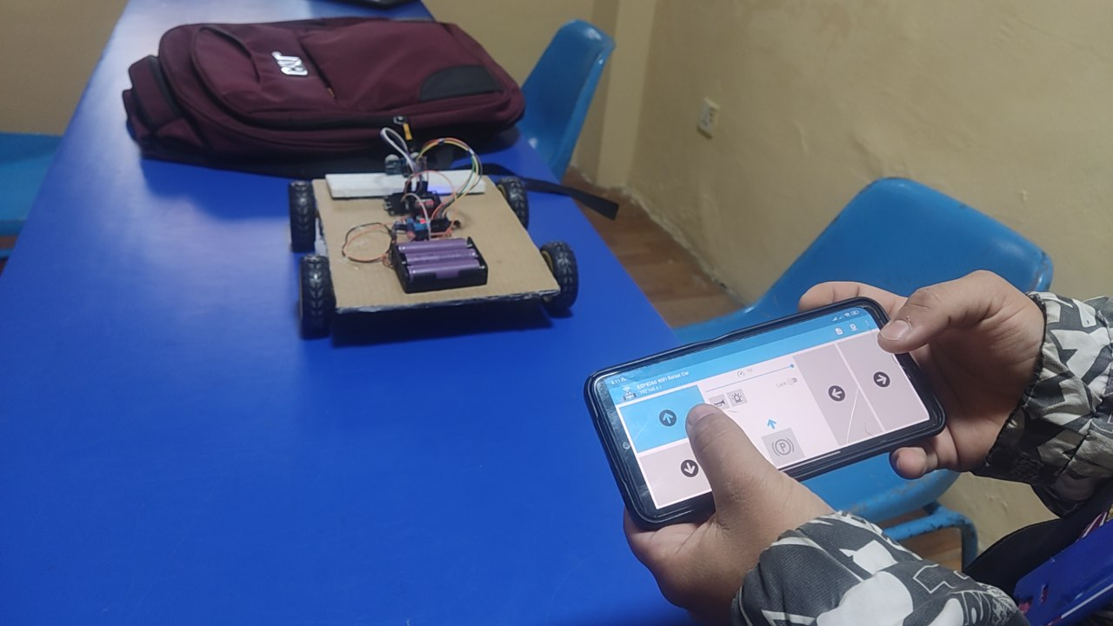

Figure 12: Detected the object and stopped.

# 5. Future Works

Here are some additional future use or purposes of our IotT project i.e. Smart car with its future use goals:

## 5.1 Home Monitoring

**a. Overview**

* Using smart car to keep an eye on the house and revert to us if anything is not normal.
* It checks at house for any unsuitable happenings.

**b. Example**

**Materials Needed:** cameras, motion sensors, Raspberry Pi, Wi-Fi.

**c. How to Implement**

* Attaching a camera and motion sensors as additional to smart car.
* Giving a command to the car to navigate around the house and detect anything unusual.
* Sending data through Wi-Fi, it drops an alert message if it finds something while scanning.

**d. Future Purpose**

* Using smart car to keep an eye and if it finds something unusual activity, it will send an alerts message

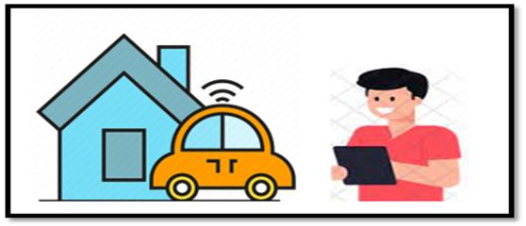

## 5.2 Voice Control

**a. Overview**

* Tell the smart car what to do and talk to it.
* Giving your voice the ability to make things move or capture moments.

**b. Example**

**Materials Needed:** A smart car with a microphone, speaker, RPi, software.

**c. How to Implement:**

* Adding a microphone and speaker to a car.
* Making it capable of recognizing voice commands using special software.
* Tell the car to "Go forward" or "Take a picture" and the car will listen and follow these commands.

**d. Future Purpose**

* Talking to the smart car and telling it what to do, like move forward, move right, left or take pictures.

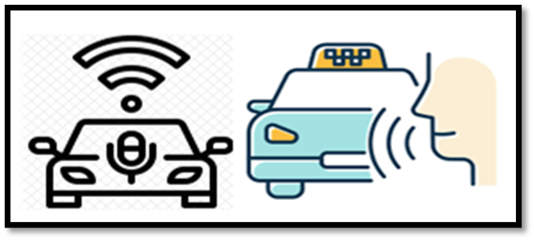

## 5.3 Photography & Videography

**a. Overview**

* Make the car intelligent and capture pictures and videos with it.
* Command the car from your phone to capture the best angle picture or video

**b. Example**

* **Materials Needed:** Sensors, camera, microcontroller (like Raspberry Pi), Wi-Fi, mobile application.

**c. How to Implement**

* Adding a camera to the smart car.
* Programing to take pictures and videos.
* Utilizing a phone app and indicating the car as to when to take a picture/video.

**d. Future Purpose**

* Use the smart car to take pictures and videos from various places.

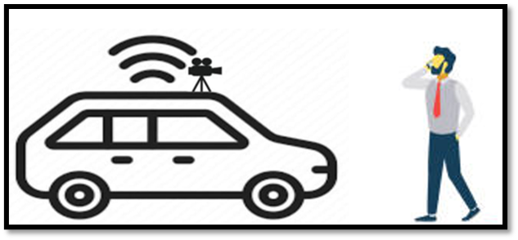

Overall, adopting these Future use goals will fulfil the need for more flexibility and usefulness in the implementation of the IoT Smart Car project.

# 6. Conclusion

In conclusion, the project ended successfully since we created the design and the implementation of a remote-controlled car prototype with the use of the Internet of things. Using Wi-Fi networks and obstacle detection systems, we designed a flexible and operational vehicle. Our comprehensive testing covered all features, from obstacle detection to make the design well integrated. Although we had problems and faced them during the testing of the hardware components, we managed to solve them, and we got the successful result our project provides multiple areas of potential future uses. Others are namely home monitoring, voice control, and privacy or video services, which will lead to an improvement of the general function and utility of the car the project not only met its objectives but as well showed how IoT can find more applications and evolve in the field of car engineering and development.